OCTOBER 31
Hieromartyr Archpriest John Kochurov.

At “Lord, I call…” – Tone 5

8. Out of the depths I cry to Thee, O Lord!
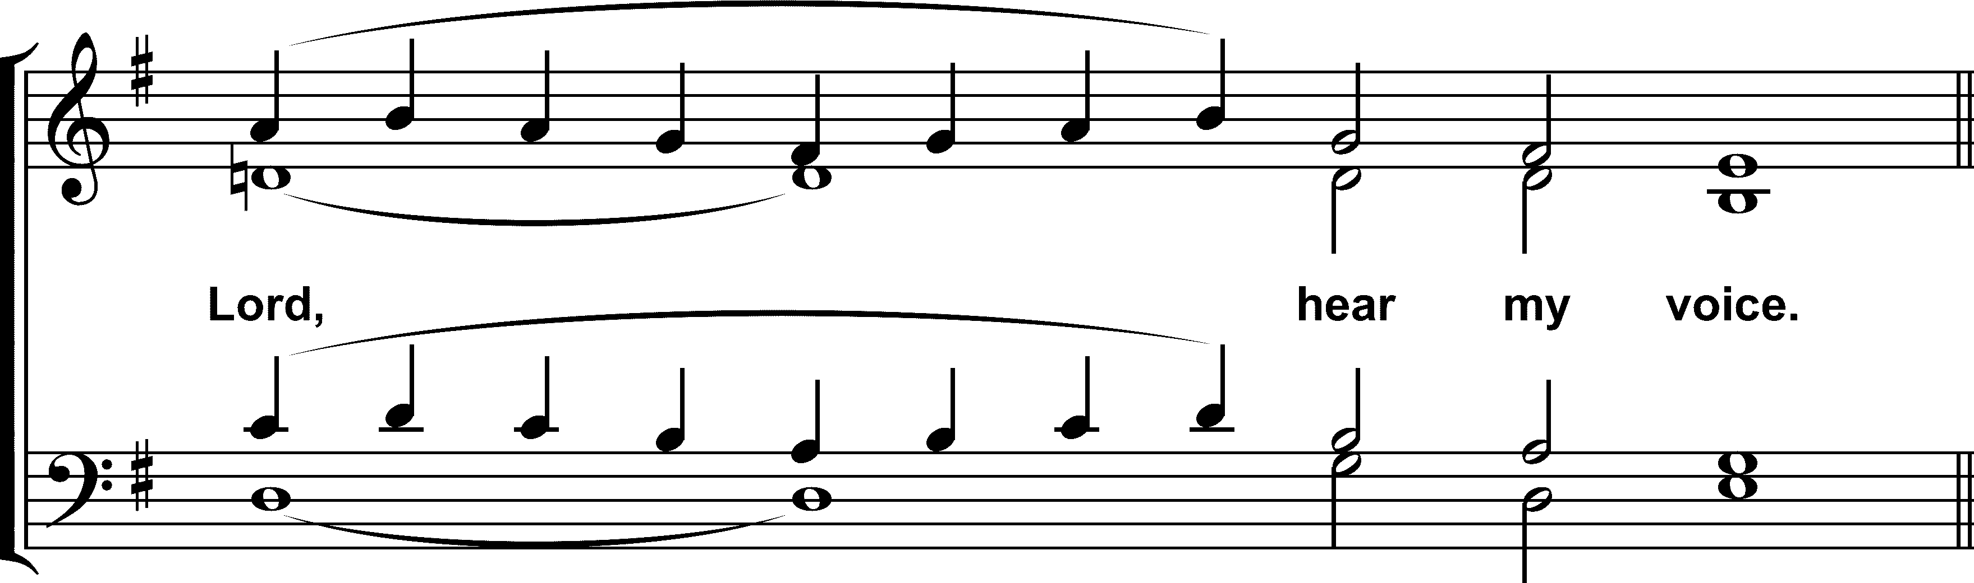

(“Rejoice”)

Rejoice, O true apostle of Christ!
In the Apostles’ path of virtue didst thou endure;
to our land didst bring thỳ family
to serve the people of Christ.
By thy patience, love and great long-suffering
to lay a foundation firm in the midst of òur native land
didst plant the Faith of the Apostles, O holy one,
in all things obeying the Will of God faithfully.
Wherefore, as we now enter the Cathedral whìch thou didst build,
we ask by thine intercessions that we may find God’s great love for man,
O John, thou good shepherd,//
and that peace and His great mercy be granted to the world.

5. For Thy name’s sake I wait for Thee, O Lord. My soul has waited for Thy word,
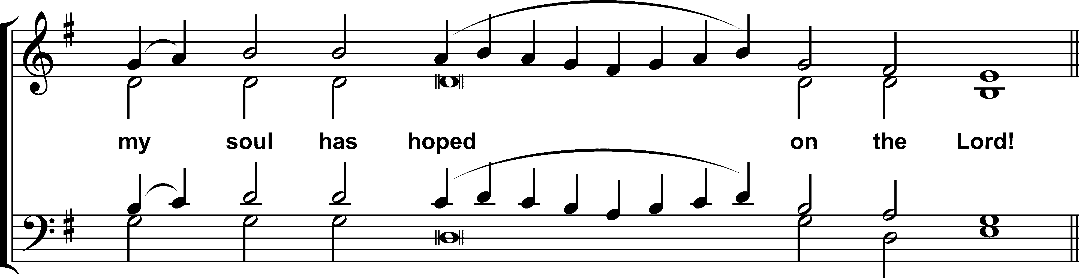
Rejoice, O faithful servant of Christ!
Thy life was like one of the righteous of ancient times.
Like Abrahàm thou didst leave
thy familiar homeland behind,
coming to the New World, O inspired one.
Not losing thy faith in God, thou didst labor mòst valiantly,
guiding thy flock amidst a land full of strange beliefs
as the Patriarch long ago did in Canaan’s land.
Firmly didst thou establish the True Faith, preachìng zealously.
Hence, we entreat thee to pray to Christ that He strengthen His holy Church,
O John, thou true pastor,//
and that peace and His great mercy be granted to the world.

Glory in the 6th Tone.
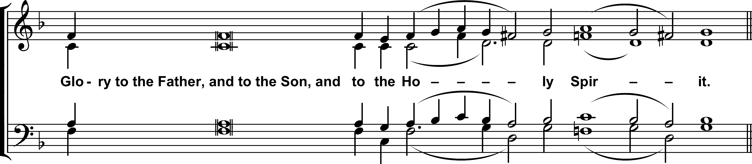

(Idiomelon)

Rejoice, O Chicago!
Leap for joy, Tsarskoe Selo,
hallowed by the life and labors of the righteous priest,
the faithful John, the martyr of Christ,
who with zeal defended the Truth,
saving those gone astray on the paths of falsehood.
A true shepherd of the rational sheep of Christ:
with holy Tikhon and Alexander,
he brought the light of Orthodoxy to the lands of America,
and struggled unto death in the lands of Russia
against the powers of godlessness
that like wolves were ravaging the flock of Christ.
Now he intercedes before the throne of God//
for the peace of the world and the salvation of our souls!
Now and ever, the Dogmatikon in the same tone.
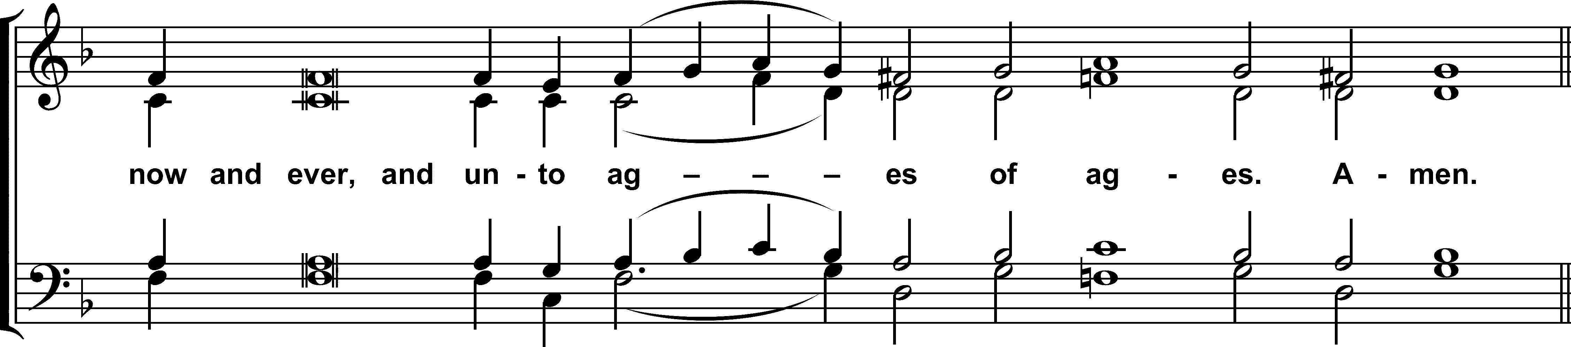

Who will not bless thee, O most holy Virgin?
Who will not sing of thy most pure child-bearing?
The only-begotten Son shone timelessly from the Father,
but from thee He was ineffably incarnate,
God by nature, yet Man for our sake,
not two persons but One, known in two natures.
Entreat Him, O pure and all-blessed Lady,//
to have mercy on our souls!
1. The reading from the Acts of the Holy Apostles.

In those days, as the apostles were speaking to the people, the priests and the captain of the temple and the Sadducees came upon them, annoyed because they were teaching the people and proclaiming in Jesus the resurrection from the dead. And they arrested them and put them in custody until the morrow, for it was already evening. But many of those who heard the word believed; and the number of the men came to about five thousand. On the morrow their rulers and elders and scribes were gathered together in Jerusalem, with Annas the high priest and Caiaphas and John and Alexander, and all who were of the high-priestly family. And when they had set them in the midst, they inquired, “By what power or by what name did you do this?” Then Peter, filled with the Holy Spirit, said to them, “Rulers of the people and elders, if we are being examined today concerning a good deed done to a cripple, by what means this man has been healed, be it known to you all, and to all the people of Israel, that by the name of Jesus Christ of Nazareth, whom ye crucified, whom God raised from the dead, by him this man is standing before you well. This is the stone which was rejected by you builders, but which has become the head of the corner. And there is salvation in no one else, for there is no other name under heaven given among men by which we must be saved.”

2. The reading from the Acts of the Holy Apostles.

In those days, when the Jews saw the boldness of Peter and John, and perceived that they were uneducated, common men, they wondered; and they recognized that they had been with Jesus. But seeing the man that had been healed standing beside them, they had nothing to say in opposition. But when they had commanded them to go aside out of the council, they conferred with one another, saying, “What shall we do with these men? For that a notable sign has been performed through them is manifest to all the inhabitants of Jerusalem, and we cannot deny it. But in order that it may spread no further among the people, let us warn them to speak no more to any one in this name.” So they called them and charged them not to speak or teach at all in the name of Jesus. But Peter and John answered them, “Whether it is right in the sight of God to listen to you rather than to God, ye must judge; for we cannot but speak of what we have seen and heard.” And when they had further threatened them, they let them go, finding no way to punish them, because of the people; for all men praised God for what had happened. For the man was more than forty years old, on whom this sign of healing was performed.
3. The reading from the Acts of the Holy Apostles.

In those days, when the apostles were released, they went to their friends and reported what the chief priests and the elders had said to them. And when they heard it, they lifted their voices together to God and said, “Sovereign Lord, Who didst make the heaven and the earth and the sea and everything in them, who by the mouth of our father David, thy servant, didst say by the Holy Spirit, ‘Why did the Gentiles rage, and the peoples imagine vain things? The kings of the earth set themselves in array, and the rulers were gathered together, against the Lord and against his Anointed’ — for truly in this city there were gathered together against thy holy servant Jesus, whom thou didst anoint, both Herod and Pontius Pilate, with the Gentiles and the peoples of Israel, to do whatever thy hand and thy plan had predestined to take place. And now, Lord, look upon their threats, and grant to thy servants to speak thy word with all boldness, while thou stretchest out thy hand to heal, and signs and wonders are performed through the name of thy holy servant Jesus.” And when they had prayed, the place in which they were gathered together was shaken; and they were all filled with the Holy Spirit and spoke the word of God with boldness.
OCTOBER 31
Hieromartyr Archpriest John Kochurov.

At the Litya – Tone 4

Temple Stikheron. Then:

In thy death, as in thy life,
thou didst testify to the truth of the Gospel,
O holy hieromartyr John,
and didst bear witness
that piety has not utterly vanished from the earth,
since in these latter years, as in early times,
the Orthodox Church inspires her children
to embrace the struggle of martyrdom.
Wherefore, fill our hearts with zeal and love,
that we also may not be found lacking//
in time of great tribulatiòn, Ò saint of God.

O namesake of grace,
thou wast resplendent with all the virtues;
with the apostles thy sound went forth into all the earth,
proclaiming the Word in a distant land;
and with the martyrs thou didst imitate the sufferings of Christ.
Wherefore, the Lord has exalted thy pure soul
to the heights of heaven,
where thou dwellest in God for all eternity.
O glorious hieromartyr,
in thy fatherly love look down with pity
on those who undergo misfortunes and trials;
and hearken unto us who reverently invoke thy name,//
O wondrous John, thou blèssèd martyr.
Tone 2

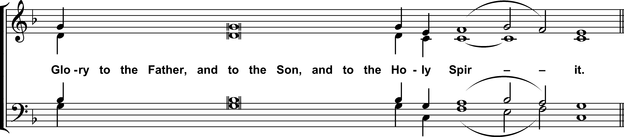

(Idiomelon)

Holy John, thou priest and martyr,
in Chicago thou didst build a great temple for the Trinity,
and in Russia, thou becamest a mastèr architect,
by thy words and deeds adding soul upon soul,
as living stones of the Church,
sealing thy work with the mortar of thỳ blood.
And now thou hast entered beyond the veil,
into the tabernacle not made with hands,
where, in Christ, thou dost intercede for us before thè Father,//
that we may receive grèat mercy!

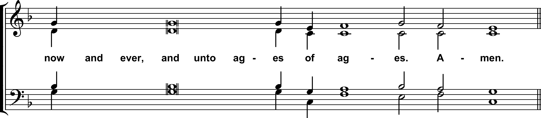

(Theotokion)

Like a fruitful olive tree,
the Virgin put Thee forth as the Fruit of life,//
to bring forth as fruit for the world great and rìch mercy.
OCTOBER 31
Hieromartyr Archpriest John Kochurov.

Apostikha – Tone 4

(“As one valiant among the martyrs”)

When like ravening wolves
the ungodly pursued thee as their prey,
thou didst not resort to flight, O martyr of Chirst,
but didst seek to allay their savagery with peaceable words.
In this thou didst show thyself to be not a hireling,
but a good shepherd who laid down his life for his sheep.//
Wherefore, we cherish thy sàcrèd memory with faith.

v. Thy priests shall be clothed with righteousness
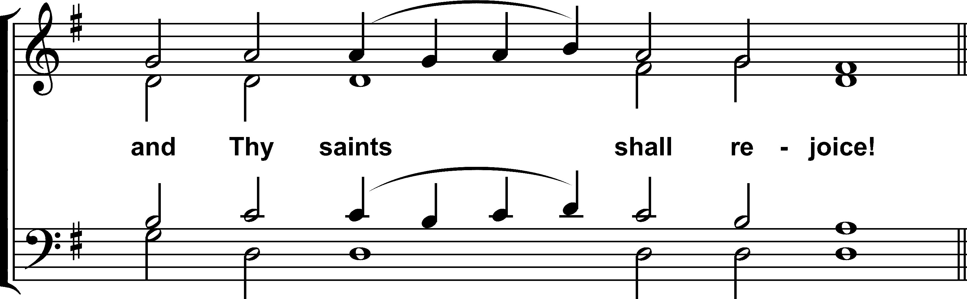

Like Christ thy Master,
thou didst endure mockery and smiting at the hands of the ungodly,
yet didst remain steadfast in holiness.
Wherefore, thou didst undergo martyrdom,
the first of the priests of the Church of Russia
to lay down his life for Christ his Lord,
Whose name thou didst glorify most excellently//
by imitating His salvìfìc sufferings.
v. Precious in the sight of the Lord
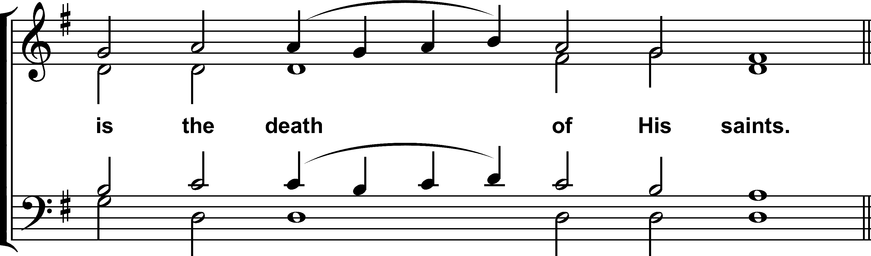

Zealous for Christ,
thou didst upbraid the ungodly
who were raging like the heathen
and in their godless doctrine imagined a vain thing;
but, deaf to thy righteous admonitions,
they vented their malice upon thee, and put thee to death,
like as the throng stoned the protomartyr Stephen of old,//
O John, first martyr among the priests of Russia.

Glory in the 5th Tone.
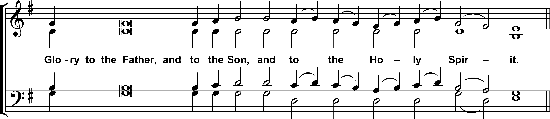
(Idiomelon)

O thou strength and comfort of thy people,
thou shepherd of thy sheep and their servant,
thou hast fed thy people on the verdure òf Mysteries of Christ;
holy John, thou didst prepare for them
a Table in the midst of their enemies,
leading them through the valley of thè shadow of death.
In thee there was no condemnation or spite
for those whose fighting brought sorrows and troubles to thy flock,
but thou thyself didst lay down thỳ life for the sheep,
united to thy Lord in death,
and through him entering into abundant life,
carrying upon thỳ shoulders//
the rational sheep of Christ.

Now and ever, the Theotokion in the same tone.
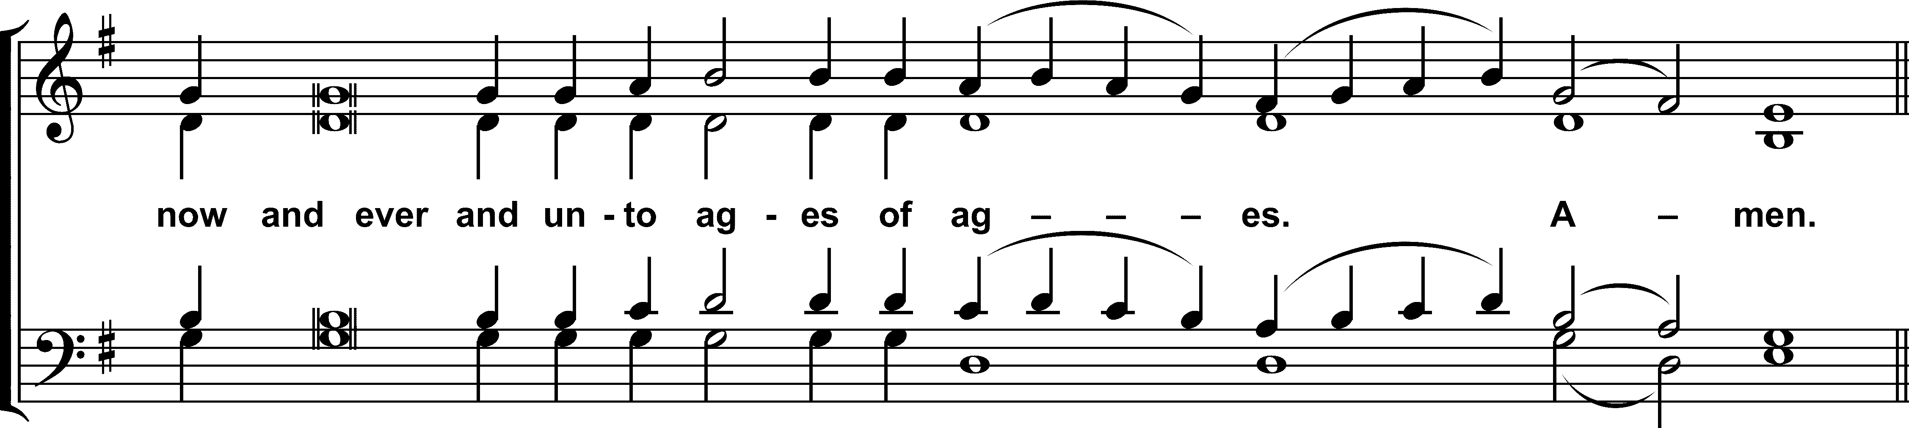

O most precious Virgin!
Thou art the gate, the temple,
the palace, and thè throne of the King!
From thee my Redeemer, Christ the Lord,
appeared to those asleep in darkness!
He is the Sun òf Righteousness
Who desired to enlighten His image, whom He had created!
Since thou dost possess motherly boldness before Him, O all-praised Lady,//
pray unceasingly that our souls may be saved!
OCTOBER 31
Hieromartyr Archpriest John Kochurov.

Post-Gospel Stikhera – Tone 6

Glory to the Father, and to the Son, and to the Holy Spirit.
Through the prayers of the Hieromartyr John,
O Merciful One,//
blot out the multitude of our transgressions!

Now and ever and unto ages of ages. Amen.
Through the prayers of the Theotokos,
O Merciful One,//
blot out the multitude of our transgressions!

Have mercy on me, O God,
According to Thy great goodness;
and, according to Thine abundant mercy,//
blot out my transgressions!

Come, ye assembly of the Orthodox,
and with reverence let us honor John the hieromartyr,
entreating him most earnestly,
that by his supplication he strengthen us
in our hour of temptation,
lest, unto our perdition, we deny that we are Christians;
for he prevailed over the godless ones who slew him,
and spared not his body
that he might acquire the pearl of great price.
Wherefore, let us honor his great courage and endurance,
crying out to Christ with boldness:
O Lord, through the prayers of Thy glorious martyr,
vouchsafe unto us the blessings of heaven,//
in that Thou art good and lovest mankind.
OCTOBER 31
Hieromartyr Archpriest John Kochurov.

At Lauds – Tone 8

4. Praise Him for His mighty deeds;
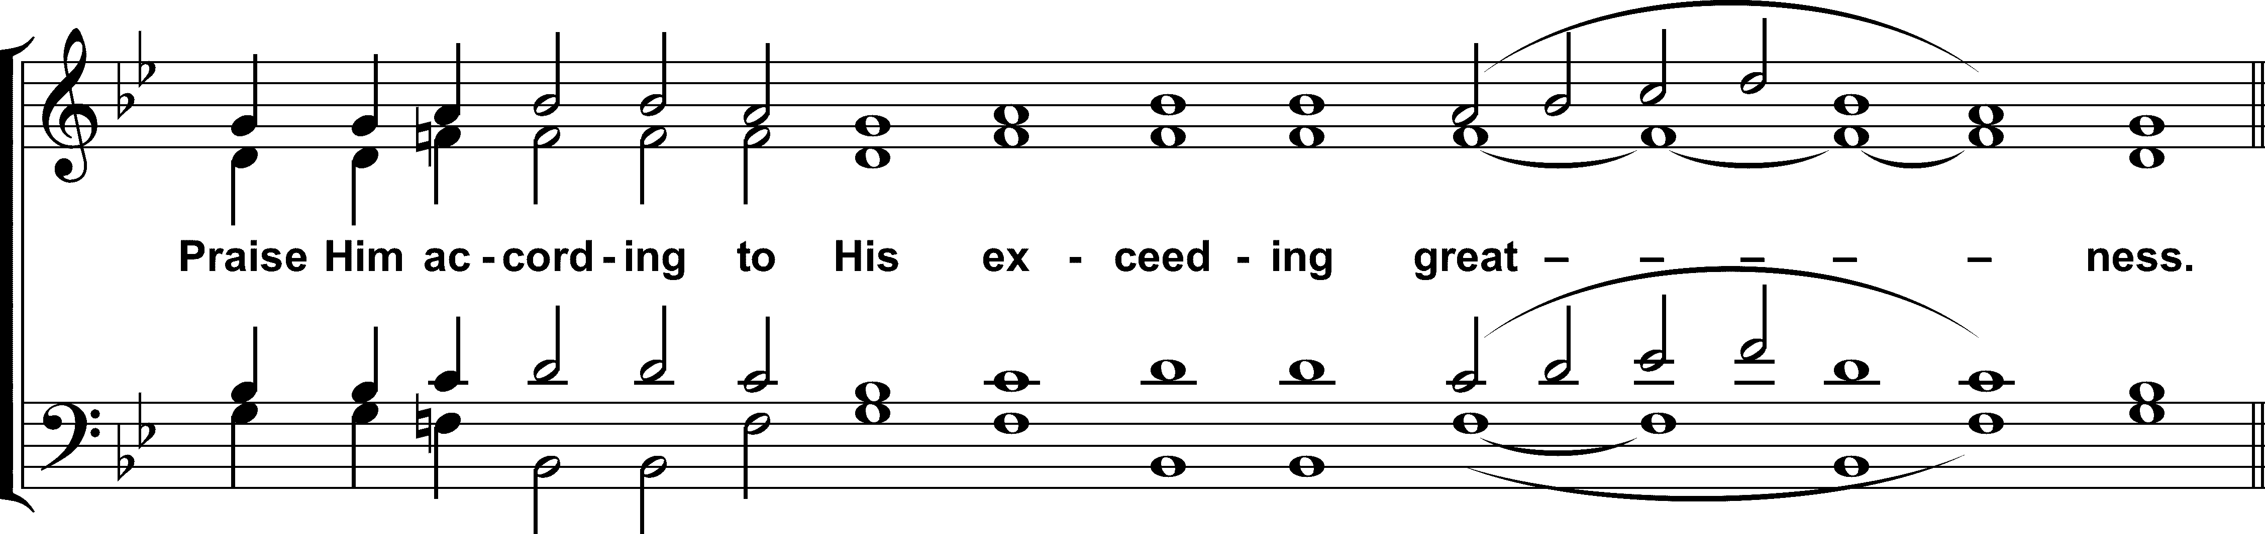

(“What shall we call thee”)

What shall we call thee, O martyr?
Lampstand, holding up the light of Christ for all to see;
River, watering our land by thy words and deeds;
Beacon, guiding those surrounded by darkness;
Lamb, for thou wast led to the slaughter;
Stone, for thou wast rejected;
Foundation, for the Lord built his Church on thee.//
Do thou pray that our souls may be saved!

3. Praise Him with trumpet sound;
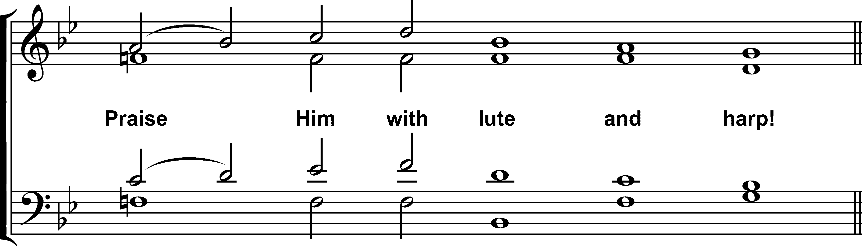
To whom shall we liken thee, O holy one?
Zachariah, as the fruit of a priestly family;
Solomon, for thou didst build a great temple for God;
Moses, for thou didst lead thy people through the wilderness;
Noah, preserving thy people amid a destroying flood;
The noble Joseph, for in the darkest hour thou didst not forsake Christ;
Stephen, for thy persecutors could not silence thee.//
Do thou pray that our souls may be saved!

2. Praise Him with timbrel and dance;
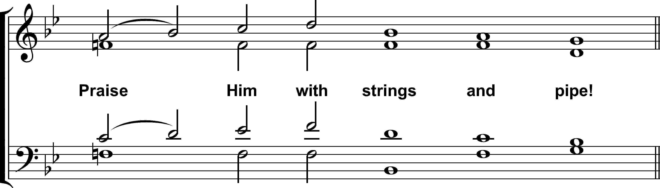

With what title shall we honor thee, O saint of Chicago?
Confessor, proclaiming the Gospel amid great testing;
Teacher, instructing us in divine truths;
Mentor, for thou givest us an example of a virtuous life;
Guardian angel, watching over and protecting us;
Shepherd, who hast defended thy flock even unto death;
Priest, who dost ever intercede for us.//
Do thou pray that our souls may be saved!

1. Praise Him with sounding cymbals; praise Him with loud clashing cymbals!
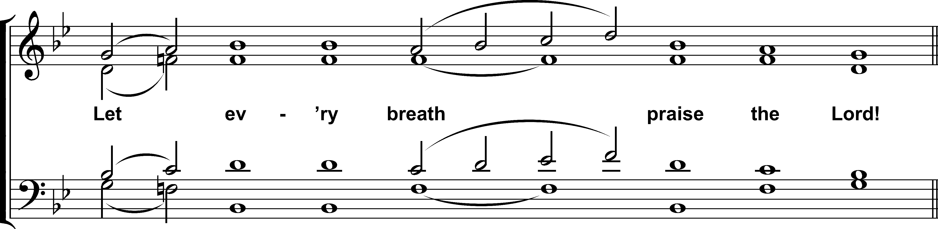
How shall I now address thee, O righteous one?
True disciple of Christ following the way of the Cross;
Apostle, bringing the faith to a new land;
Priest, united to the sacrifice of Christ;
Martyr, bearing witness even to the shedding of thy blood.
Many are thy names, O John,
and greater still are thy divine gifts.//
Do thou pray that our souls may be saved.

Glory to the Father, and to the Son, and to the Holy Spirit.

Reader: [Doxasticon]

Now and ever, the Theotokion in the 8th Tone.
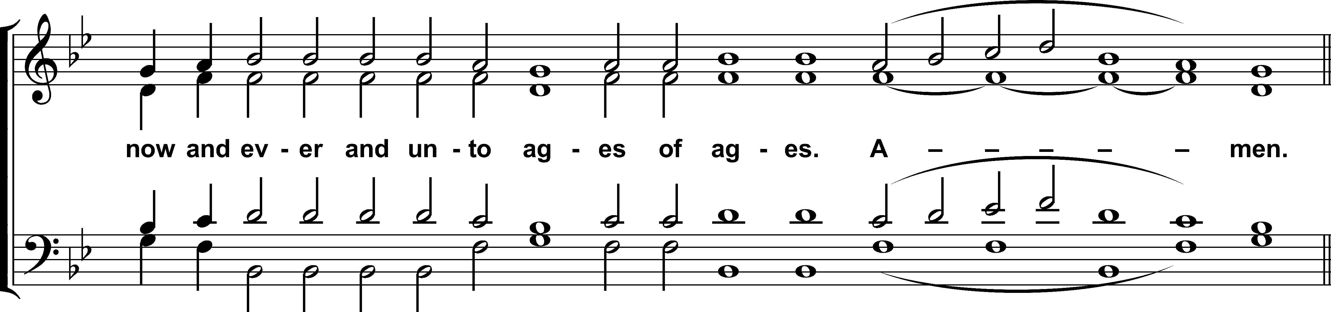

O Mistress, accept the supplications of thy servants,
and deliver us//
from all want and grief.

